CVI620 – Assignment 2
Fall 2025

Total Mark: | 7.5 marks (7.5% of the total course grade)
Submission file(s): | - Python files for train and inference
Deadline | - November 27th, 2025

If you are unable to complete the assignment on-time for any legit reason, please provide documentation explaining your absence (e.g., an appointment confirmation or a work letter).

Please submit the submission file(s) through Learn@Seneca. Make sure to use GitHub and provide the link to your GitHub account for all your contributions in the box below:
Project GitHub repository: | https://github.com/yachna3010/CVI620NSB/tree/main/Assignment%202

Please attach some of your test images along with any required explanations in this document.

- For the Cat and Dog dataset provided in the Q1 folder, perform classification using all the methods you know and try to achieve the best possible result. Compare the algorithms carefully and tune the parameters so that the best result can be obtained.
Save the trained model and test it on several images from the internet. Was the model able to correctly predict the images?

Answer:-
During the Cat and Dog task, I applied three diverse models to find out which one could differentiate cats from dogs the best. The models were Logistic Regression, Random Forest, and SVM. After the training, the SVM model was found to be the best one, however, it achieved only around 60% accuracy still. I kept this model and tested it with 10 new images that I got from the internet. Out of these 10 pictures, it was right about 4 of them. The model did not perform well because the internet pictures were very different from the training ones. There were differences in lighting, angles, and backgrounds. Thus, the model performed fair on the training data but was not very consistent in real-world pictures testing.

- The MNIST dataset is one of the most well-known datasets in the field of image processing. It contains 60,000 images related to handwritten digits from 0 to 9 and is provided as a CSV file in the Q2 folder. In this file, each image is represented as a flattened vector. Classify this dataset using different methods and try to achieve at least 90% accuracy.
ANSWER:-
In the MNIST handwriting numbers classification, I included the same three models as in Question 1: Logistic Regression, Random Forest, and an MLP Neural Network. The MNIST data set is undoubtedly much cleaner and more consistent than photos of real animals because all the images are centered, grayscale, and the same size. After each model was trained, the MLP Neural Network was the best one with a validation accuracy of around 97.95%, which is already much higher than the 90% required. The final model tested on the 10,000 official images gained approximately 97.93% accuracy. This indicates that it was able to recognize almost every handwritten digits correctly. I realized that neural network was very efficient because it is capable of learning complex patterns and dealing with slight variations in handwriting, while simpler models cannot so much. In conclusion, this part of the project was very easy and the MLP model was a powerful technique for this kind of image classification.

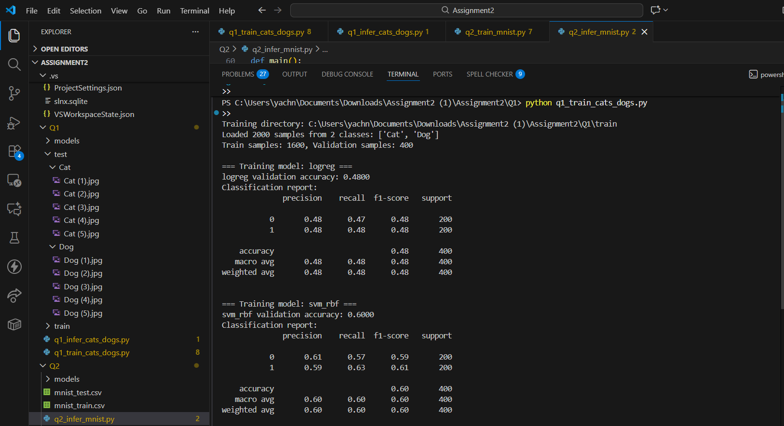

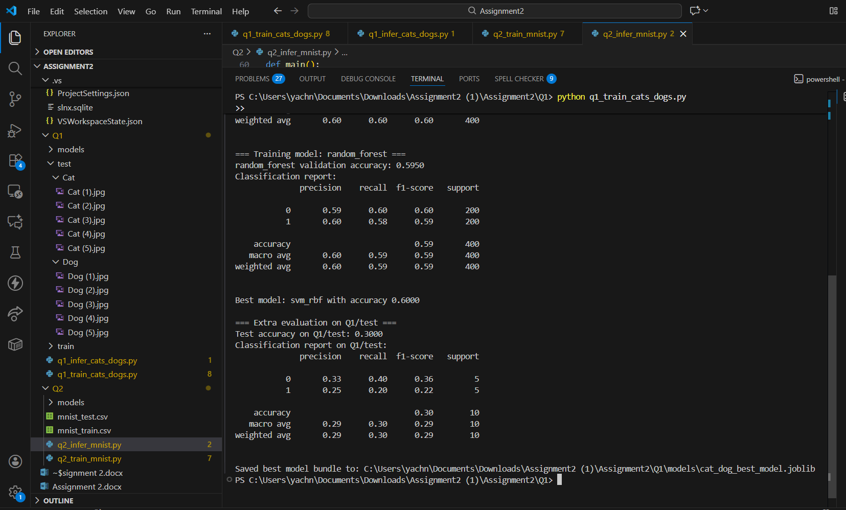

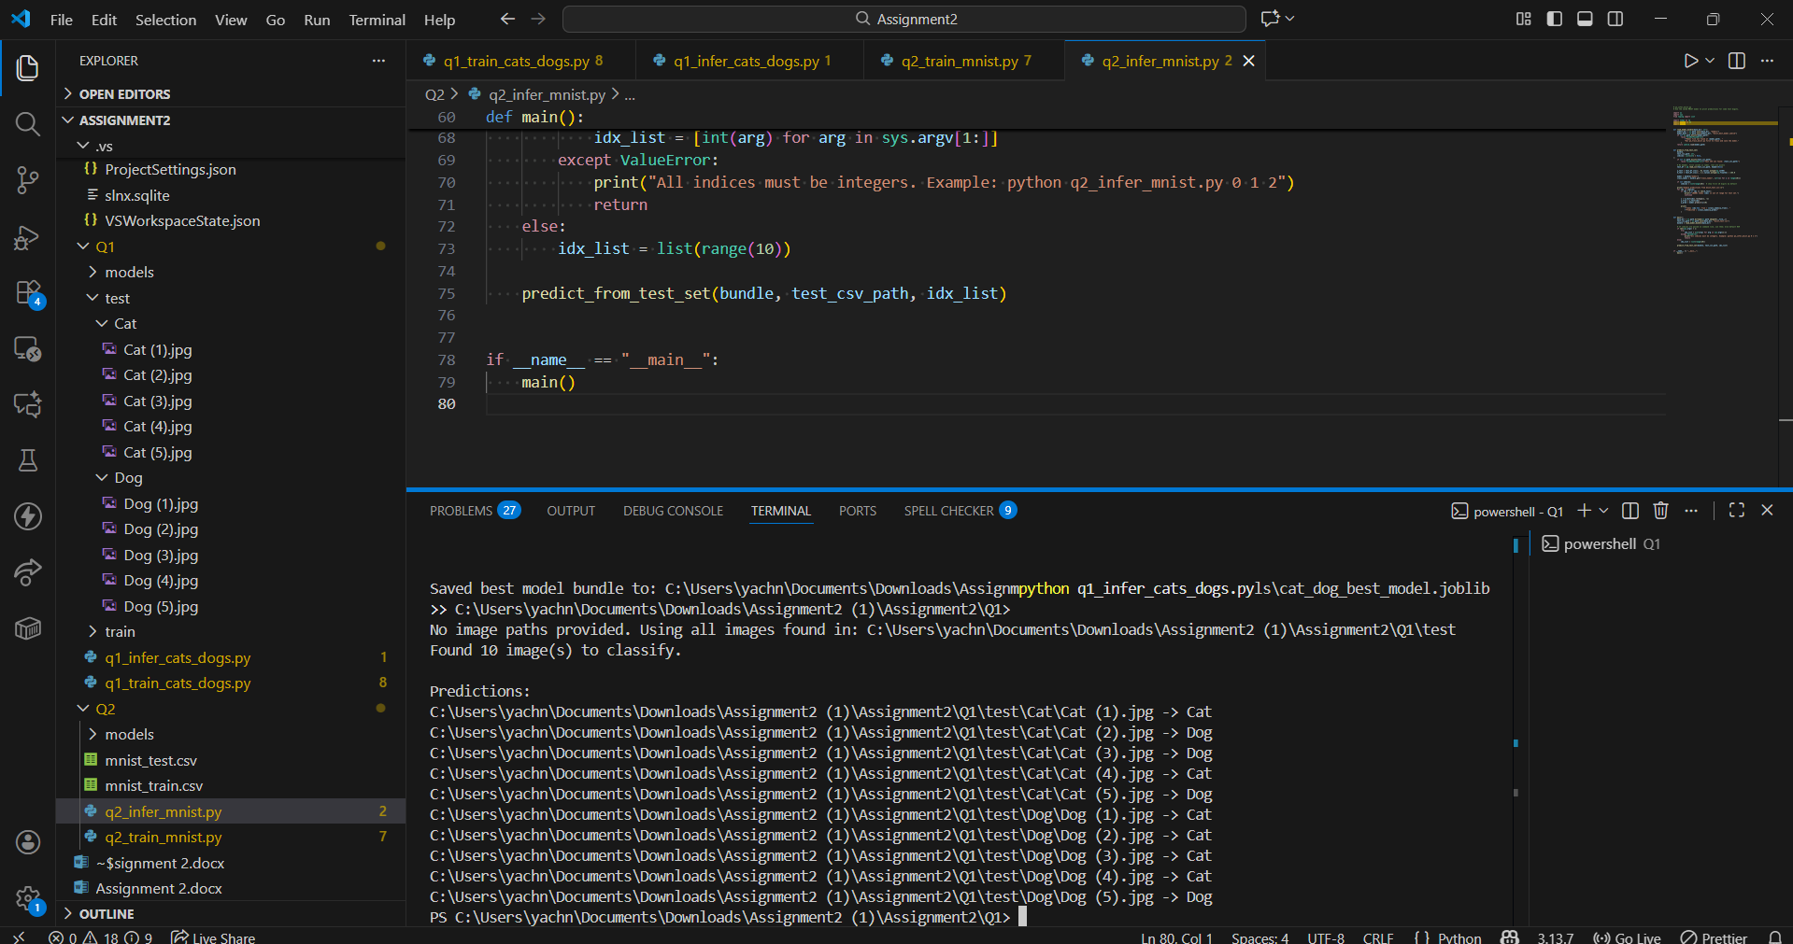

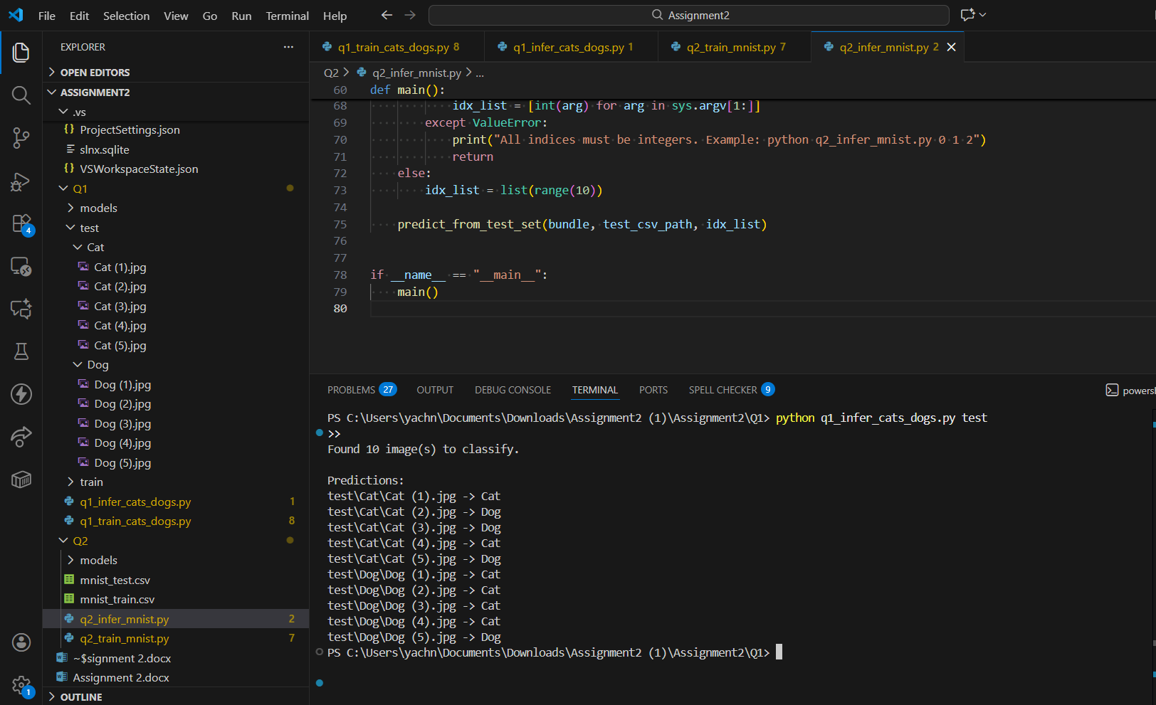

Question2
